**“SimpleCademy: A Student -Teacher Online Portal ”**

Report Submitted in partial fulfillment of the award of degree of

Bachelor of Engineering

(Computer Science & Engineering)

Submitted by:

Anuj Shaha

Anurag Wankhede

Ashutosh Patil

Rahul Pariyani

B.E., Computer Science Engineering

JIT, Nagpur

Guided by:

Mr. Ashish Kumbhare

Asst. Professor, Computer Science Engineering



Department of Computer Science & Engineering

Jhulelal Institute of Technology

2019-2020

**CERTIFICATE**

This is to certify that the report entitled **“SimpleCademy: A Student -Teacher Online Portal ”**

submitted to the Rashtrasant Tukdoji Maharaj Nagpur University, Nagpur in partial fulfillment of the requirement for the award of a degree of Bachelor of Engineering in Computer Science & Engineering. The record of the candidates own work carried out under our supervision at the Department of computer Science and Engineering, Jhulelal Institute of Technology, Nagpur during the academic year 2019-20. The matter embodied in this report is original and has not been submitted for the award of any other degree.

*Mr. Ashish Kumbhare*

*Asst Prof,CSE JIT*

*Project Guide*

*Mrs. Mona Mulchandani Dr. Narendra Bawane*

*HOD, CSE Principal*

*JIT, Nagpur* *JIT, Nagpur*

Department of Computer Science & Engineering

Jhulelal Institute of Technology

Session 2019-20

**DECLARATION**

We hereby declare that the report titled “**Simple Cademy: A Student-Teacher Online Portal”** submitted herein has been carried by us in the Department of Computer Science Engineering, Jhulelal Institute of Technology, Nagpur. The work is original and has not been submitted earlier as a whole or in part for the award of any degree / diploma at this or any other Institution / University.

Date: *Anuj Shaha*

*Anurag Wankhede*

*Ashutosh Patil*

*Rahul Pariyani*

B.E, Computer Science Engineering

JIT, Nagpur, India.

Department of Computer Science & Engineering

Jhulelal Institute of Technology

Session 2019-20

**ACKNOWLEDGEMENT**

We would like to take this opportunity to acknowledge our profound indebtedness and extend our deep sense of gratitude to our respected guide Mr. Ashish Kumbhare, Department of Computer Science & Engg. For their valuable guidance, profound advice and encouragement that has led to the successful completion of this project.

We are grateful to our respected HOD Ms. Mona Mulchandani, Department of Computer Science & Engg for her full cooperation and help. We also thank the staff members of the CSE department.

Our sincere thanks to respected Dr. Narendra Bawane, Principal, JIT, for providing the necessary facility to carry out the work.

We would like to thank all the people who have directly and indirectly help us in the completion of project.

Finally we would like to express our deepest gratitude to our parents for encouraging through the progress in the work.

**ABSTRACT**

One of the important services that universities currently depend on is a student portal where Students can check information related to their study and affairs. This service is one of the knowledge management tools. This portal allows the users to fetch the study material uploaded by the faculties of their own subject. Online Portal is designed to implement digitalization and reducing work of college staff/faculty like providing same notes repeatedly to each student every time. The online lectures link also provides the ease to study the missed topics easily. This paper is to: empirically validate a modified unified theory of acceptance and use of technology (UTAUT) model by adding an “e‐learning motivation”.

**INDEX**

**Page No.**

*Title*

*Certificate*

*Declaration*

*Acknowledgement*

*Abstract i*

*List of figures ii*

*List of tables iii*

*List of Abbreviations iv*

**CHAPTERS**

1. **INTRODUCTION 1**

**2. Literature Survey 2**

**3. PROBLEM STATEMENT AND OBJECTIVE 4**

**4. PROPOSED SYSTEM 5**

**5. FLOWCHART/DATA FLOW DIAGRAM 6**

**6. SOFTWARE & HARDWARE REQUIREMENT 9**

**7. IMPLEMENTATION 10**

**8. RESULT ANALYSIS & DISCUSSION 13**

**9. CONCLUSION AND FUTURE SCOPE 14**

**REFERENCES**

**LIST OF FIGURES**

|  |  |
| --- | --- |
| **Figure No.** | **Figure Name** |
| 5.1 | Use-Case Diagram |
| 5.2 | Overview of the Use-Case diagram |
| 5.3 | Component flow diagram |
| 7.1 | User Dashboard |
| 7.2 | Student Sign-up page |
| 7.3 | Login page |

**LIST OF TABLES**

|  |  |
| --- | --- |
| Table No. | Table Name |
| 2.1 | Literature survey |

**1. INTRODUCTION**

In the age of technology, huge amount of knowledge, information and data is being produced now a days. Gaining the knowledge, learning new technology and sharing with the society by continuously sharing the experience and knowledge we have are no longer limited to the boundaries of a class room. Currently, the number of users who can access the Internet is increasing even in countries with poor economic performances. That has led to acceleration in producing and transforming information processes. This has led to the transformation in the technology in very less time period. This project is an online portal for the students, parents and faculty. “Simple-cademy” will be developed to override the problems prevailing in the practicing manual system .This system allows college faculty to share or upload important data, notes , video links related to their subjects and as well notify about the upcoming events in the college. This system provides a faculty login along with student login & parent login. The faculty can easily upload the documents and links with the pc easily. The documents are uploaded by faculties of department to different corresponding departments. The purpose to build this system on an online server that allows faculty to upload data & students may view/search and download the required documents through their computer device or mobile application. Here students only seeand download data of their particular semester/year/class, Rest of data is hidden. Faculty may access and upload/edit documents to any semester/year/class or add any notice as their desire. The web portal provides a gate way to access information as well as search, an analytical and communication center for the target users. Most of previous research in student portal context focused on web usability, mainly from desktop and laptop computers [5]. On the other hand, many of universities already built a separate mobile-optimized design for their student portal. As costly as it could be, these mobile sites, when implemented without assessing user preference, could hold usability challenges. The system in college nowadays like entering marks , attendance ,calculating percentage , giving notices , event calendar , providing exam routine and providing notes/papers is done manually which consumes lots of time and man power.

**2. LITERATURE SURVEY**

As time advanced, many intellectuals came across with the idea to create a platform which will be beneficial to the students by making them engage with the technology for the sole purpose of using technology for educational purpose. This gave rise to people implementing this, in their own unique ways, such can viewed to have a general implementation ideology, some such portals are listed below:

|  |  |  |  |
| --- | --- | --- | --- |
| |  | | --- | | **Serial No.** | | **NAME** | **DESCRIPTION** |
| 1. | A study of web portal as a knowledge management system in school education | This focuses on the web portals and their vital role as a knowledge management system in the schools. Generally, the web portal provides a gate way to access information as well as search, an analytical and communication center for the target users. It is import and for the schools to have emphasis on knowledge sharing for supporting the students to access the required resources and information.[1] |
| 2. | The student portal performance- comparative study | Quality of student portal services provided for IIUM as well as GSM students have a significant impact on how students perceive their educational institution at large. Technical factors such as; type of service provided as well as managerial factors such as; reacting to feedback received from students are critical in shaping students’ overall perceptions on their respective institution.[2] |
| 3. | Teachers’ Readiness in Utilizing Educational Portal Resources in Teaching and Learning | In terms of expenditure, the Ministry has allocated a huge budget in developing the Eduwebtv online portal. Its aims are noble – bridging the digital gap and barriers in accessing quality educational content and resources for teachers and students, and the public in general.[3] |
| 4. | The Intention to Use Mobile Student Portal: A Mobile Human Computer Interaction Study in a University Context in Egypt | This exploratory study investigates factors affecting the intention to use mobile student portal for university students. The study was conducted in a university context in Egypt. The study aims to provide practical mobile student portal design guidelines for educational entities, designers, and implementers, to enhance students’ willingness to use.[4] |
| 5. | Online College Portal | This system, in addition to lessening the work load on the institute, it also fixes any false data about the users that the institution may have. It is a benefit for the users’ whose important time and energy is preserved, for the affected  educational college’s authority whose workload is immensely reduced, whose services are secured from misuse.[5] |
| 6. | Web portals, instant messaging and web communities | The INFNGRID support website, is only an example of a powerful collaboration tool that can be easily implemented combining open source software, such as PHP-Nuke, Jabber and the always present mailing list.[6] |

Via these above mentioned concepts of portals, it can be seen that these are the most commonly used techniques, when it comes to delivering effective and creative forms of portals, created with the sole purpose of making education system familiar and comfortable for students, whilst, they enjoy the use of technology.

**3. PROBLEM STATEMENT AND OBJECTIVE**

3.1 **PROBLEM STATEMENT**

* Existing application only shows notification panel.
* Students face the issue of not being able to find their notes.
* This will be a solution where students will be able find their notes and documents under a single interface.
* This is also beneficial to the staff for sharing the notes with their students.

3.2 **OBJECTIVE**

* To create a platform where a student can access information (academic as well as administrative) and can get the study material at ease.
* The staff can manage the academic session.
* To create a platform where parents can easily interact with teachers about academics.
* A dashboard where notifications are visible.
* Parents/students feedback dashboard.
* Document requirement request application of students.
* Relevant video links according to the subject made available.

**4. PROPOSED SYSTEM**

The portals and their usage research results show that these portals and platforms do have an assertive impact on the modern education and schooling of the students. Even when the portals were funded sufficiently the admin users tend to only use some percentage of the amazing piece of tool, which unfortunately leads to the stagnating usage of the full portal. Research shows that the versatility and expansiveness of the portal is an important factor that motivates both student and teacher to use a portal's full potential. Moreover, Web Portals are extended such that the management system of any institute is often integrated. Also, Before-mentioned portals are used to receive valuable student feedback.

The Proposed system of the portal is:

1) Institute Management System can be added.

2) Student-teacher guidance is possible even outside of the class.

3) Automation of tedious processes.

4) Student Feedback is taken into account within the portal.

5)The staff can manage the academic session.

6) Document requirement request application of students.

**5. DATA FLOW DIAGRAM**

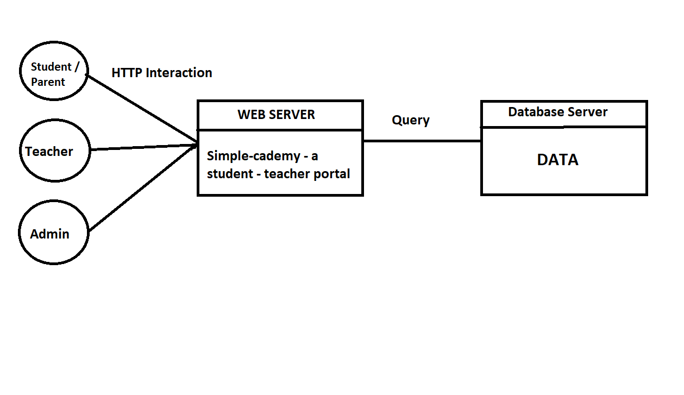Figure 5.1: Use-Case Diagram

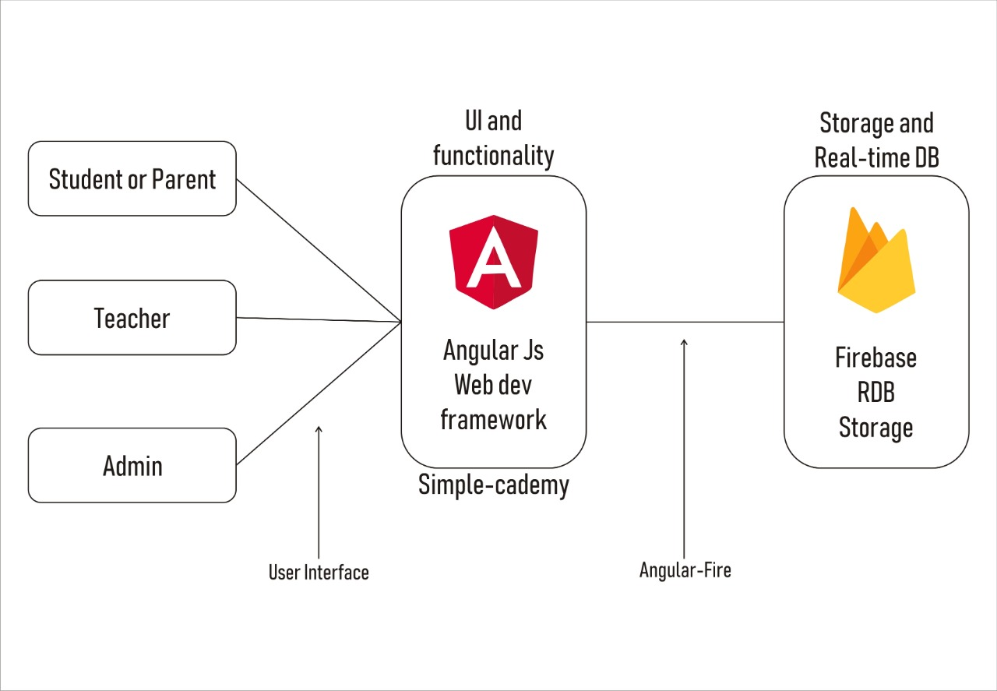

Figure 5.2: Overview of the Use-Case diagram

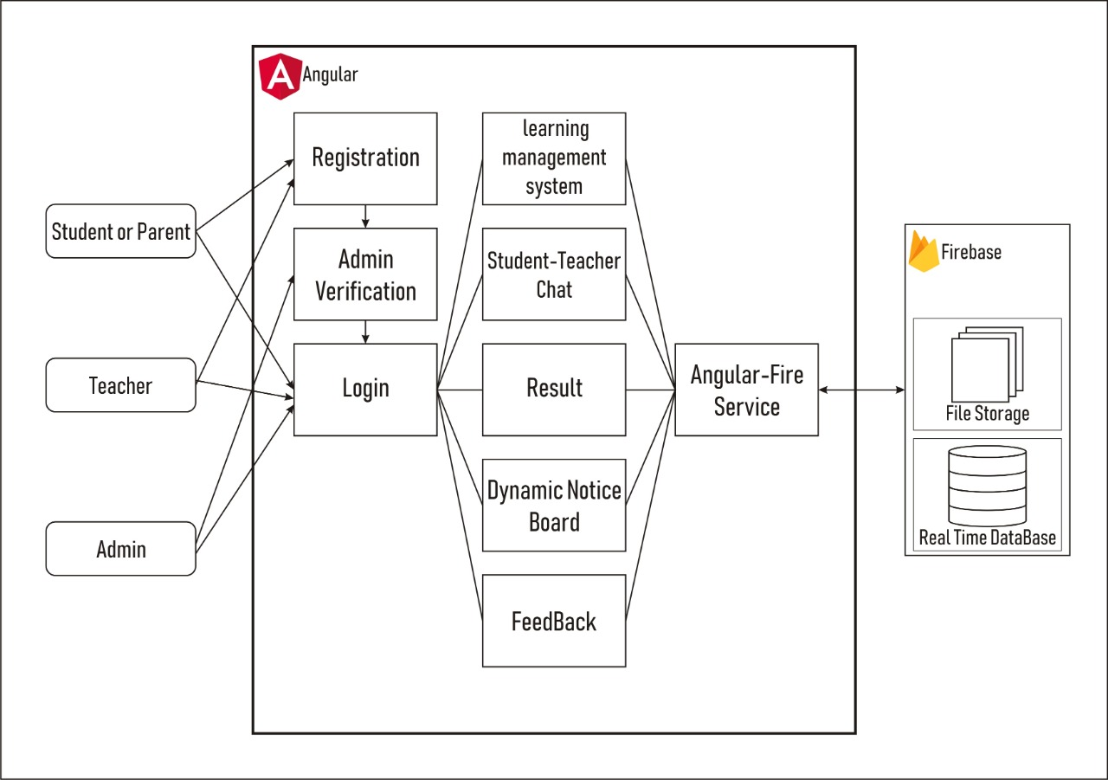

Figure 5.3: Component flow diagram

**6. SOFTWARE AND HARDWARE REQUIREMENTS**

SOFTWARE REQUIREMENTS:

* Node.js
* Visual Studio Code
* npm

HARDWARE REQUIREMENT:

* 4gb DDR4 RAM
* i3 Processor

**7. IMPLEMENTATION**

As we have discussed earlier, Simple-Cademy portal will let users to stay connected and updated about the notices, documents, study material and other things with it which helps the students to stay up to date with daily course. We are implementing this project by using nodejs development environment. We are specifically using angular cli for the front end development as well as the functionality of the project. Firebase is being used for data and file storage. Also using firebase authentication feature.

Simple-cademy is an online portal for educational institutes, that are, School Colleges, etc. Simple-cademy is a bundle features such as online learning management system, a student-teacher chat, report/result generation, dynamic notice board, student feedback system.

Simple-Cademy is built on the Angular Web Application development framework that has a component based development model. Angular uses HTML 5 for view, CSS (or other styling formats) and Type Script for functionality. Therefore, User Interface plus functions are implemented on Angular. For the Data Storage and File Storage, Firebase Real time Database and Firebase Storage are put to use. Firebase Stores data in JSON format which makes API simple and robust. Each user except admin has to firstly register and can only login after admin’s verification. After Logging in the dashboards are different based on the role of login.

For students a dashboard with option to see the notice board, chat, result, feedback(when activated by admin/teacher) will be available along with display of basic information. For Teacher a dashboard with options to see notice board, chat, result generation, feedback form generation(if permitted by admin) will be available along with display of teacher’s class student list and other basic information.

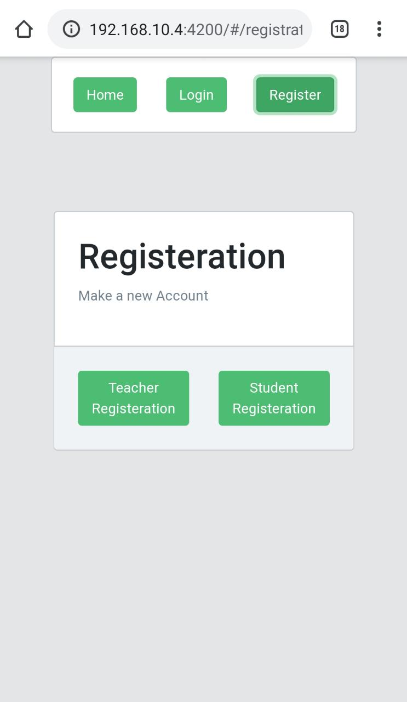

Figure 7.1: User Dashboard

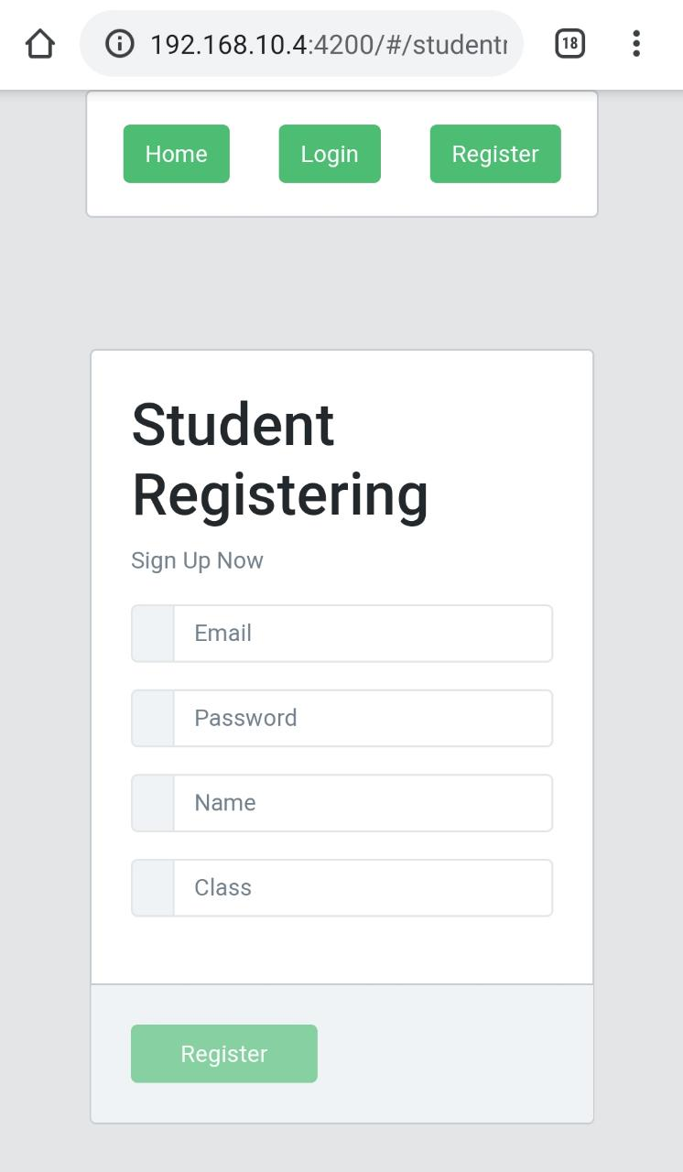

Figure7.2: Student Sign-up page

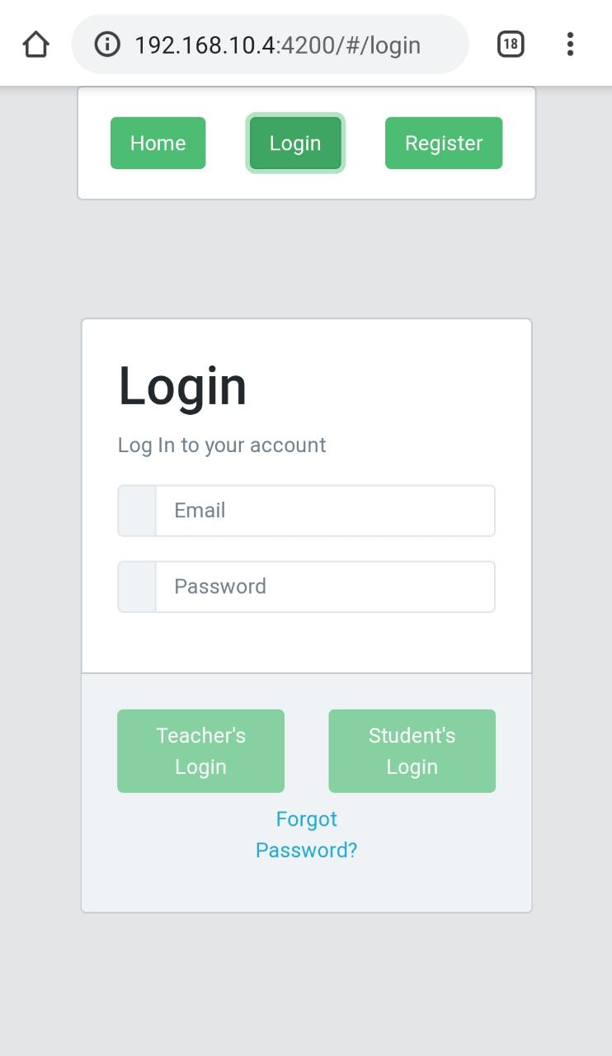

Figure7.3: Login page

**8. RESULT, ANALYSIS & DISCUSSION**

The outcome of Simple Cademy portal is that it will let all the users to gain maximum information and ease of use. As it is an user friendly portal which will help students as well as their parents to get updates about their ward and progress report . As all the event’s date will be planned those will get updated and notified to the user accordingly.

With the help of this system, student will get ample opportunities to explore the subject and learn it. This portal will reduce the burden of providing the notes to the students. It will help the administration panel to make it easy for providing documents easily and in minimum time.

**9. Conclusion and Future Scope**

**9.1 Conclusion**

This study focuses on the web portalsand their vital role as a knowledge management system in the schools. Generally, the web portal provides a gate way to access information as well as search, an alytical and communication center for the target users. It is important for the schools to have emphasis on knowledge sharing for supporting the students to access the required resources and information.

Each section will have their own functions that students can access to and gain information about the events and practices going on in the college or school. All the events and notices will be broadcasted after it is approved by the admin.

Students can search notes based on their interest in the subject and requirement. The notes are categorized and arranged according to the order of classes and their subjects. This will fecilitate students to get notes quickly and hence will reduce the searching time of the students.

Admin section will have a database that will contain entries of all the users that are registered on the portal. Admin needs to approve the entry of a user to access and enter into the portal.

**9.2 Future Scope**

To extend the application’s approach towards maximum colleges and schools in the country. All the database of the current and the ex students will be stored in the records of this portal.All the reviews and feedbacks given by the user about the portal and events in the college will be represented in analytical form.

**REFERENCES**

1. Jagtap Nilesh, Pavan Alai, Chavhan Swapnil, Bendre M.R. “Voice Based System in Desktop and Mobile Devices for Blind People”. In International Journal of Emerging Technology and Advanced Engineering, 2014 of Vol. 4, Issue: 2.
2. Pranjal Ingle, Harshada Kanade, Arti Lanke, Prof. Manasi Choche. “Voice based E-Mail System”. In International Journal for Innovative Research in Science & Technology, 2016 of Vol. 2, Issue: 10.
3. Sadaf Abdul Rauf, Mahnoor Yaqoob, Ayesha Qurban, Gulnoor Ahmad, Abdul Rauf Siddiqi, Nargis Bibi. “Voice based Interactive System for Visually Impaired”. In International Journal of Coputer Science and Information Security, 2016 of Vol. 14, Issue: 12.
4. Dhanashree D. Zope, Pooja B. Nevewani, Pooja G. Teje, Nusrat Parveen. “Voice Based E-Mail System for Blind People”. In International Journal of Scientific Research in Computer Science and Engineering, 2017 of Vol. 5, Issue: 4.
5. Swapnil Kurhade, Laxman Gore, Ketan Salve. “Voice Based Email System Application for Blind and Visually Impaired People”. In International Engineering Research Journal, 2017 of Vol. 2, Issue: 7.
6. Tharani K.K., Shalini R, Jeyathi I, Dr. Deepalakshmi R. “Voice Based Mail Attachment for Visually Challenged People”. In Internatioma Journal of Science and Engineering Research, 2017 of Vol. 8, Issue: 5.
7. K. Jayachandran, P. Anbumani. “Voice Based Email for Blind People”. In International Journal of Advance Research, Ideas and Innovations in Technology, 2017 of Vol. 3, Issue: 3.
8. Pankaj Kumar Maurya, Prince Kumar, Mukesh Kumar, Pramod Nath. “Voice Based E-Mail System”. In International Research Journal of Engineering and Technology (IRJET), 2018 of Vol. 5, Issue: 4.